Unit 3: Raising A Healthy Child
Test Review

Topic: Diapers

- Be able to list 3 pros and cons for both disposable and cloth diapers. Use the article we read in class called, “The Diaper Debate” to help you. On the test, you will not have access to the article.

Disposable |  | Cloth
1. | 1. | 1. | 1.
2. | 2. | 2. | 2.
3. | 3. | 3. | 3.

Topic: Vaccines

2. Create a vaccine schedule for a child from birth to the age of 16. Use the following website to help you (keep in mind that you will not have access to this resource on the test): http://www.health.gov.on.ca/en/public/programs/immunization/static/immunization_tool.html
1 month | 2 months | 3 months | 4 months | 5 months | 6 months
7 months | 8 months | 9 months | 10 months | 11 months | 12 months

3. Which vaccine should an expectant mother get (and why)?

4. What is diphtheria and why is it important to get the routine vaccine for it?

5. What is tetanus and why is it important to get the routine vaccine for it?

Topic: Parenting Around the World

Joanna Goddard is a mother, traveller, and blogger, who writes about her experiences and observations about parenting around the world.

6. Identify the parenting practices for each of the countries. Use the following article to help you. https://docs.google.com/a/ugcloud.ca/viewer?a=v&pid=sites&srcid=dWdjbG91ZC5jYXxocGMzb3xneDozYjE5OWM4YzhkMDY2ZmEx

Norway:

The Democratic Republic of Congo

Abu Dhabi:

India:

Australia:

Chile:

Topic: Health and Safety

7. Study the following chart. You should know how to treat the illnesses.
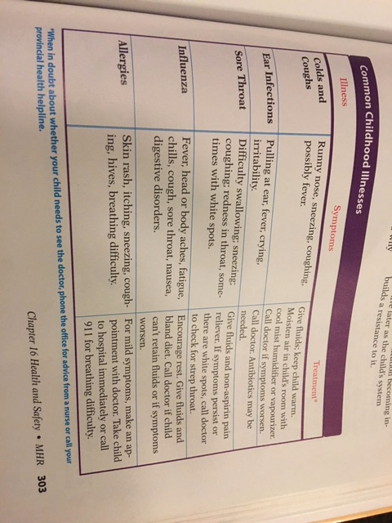

8. List three steps a parent can take to prepare for emergencies.
9. Should you induce vomiting if a child swallows a poison? Why or why not?
10. Suppose your three-year-old doesn’t like to go to the doctor. You don’t look forward to the visits either. In a paragraph, describe how you might be able to improve the visits.
11. In your own words, describe how to perform the Heimlich manoeuvre.
12. List 4 things you can do to ‘childproof’ your house. Use your ‘childproofing assignment’ as a guide.
13. Identify and define the three stages of Kohlberg’s Theory of Moral Development. Be able to give an example of each.
14. Lawrence Kohlberg (1927-1987) only used boys in his research. Based on children you know, how might that have affected his theory on moral development?

15. Kohlberg based his theory in part on Piaget’s work. Read the section on Piaget’s theory in Chapter 19. In 3-4 sentences, explain how intellectual development and moral development are linked.

16. Why is positive communication from a parent so important to a child’s well-being?

17. Which of the communication strategies do you feel would be the most difficult for a parent to use on a daily basis?

18. Be able to define the terms “nanny” and “au pair.”

19. Provide a description and example of the following terms: playgroups, non-profit centres and school-sponsored centres.

20. List the pros and cons for home-based care and centre-based care; write a paragraph about which you would choose and why. Use both facts from the text and your own ideas to support your choice.

***Please note that I will be marking your assignments (Taking Safety Precautions Questions and Kohlberg Assignment) this weekend. I will return your marked assignments to you on Monday Dec. 11th. You will not be able to study questions 16-20, as you haven’t yet done these in class. Questions 16-20 will be done in class next week.

