Practice News Report

Purpose &
Audience: To report on an event for the readers of a newspaper

Task: Write a news report based on the headline and picture below.
You will have to:
- Make up the facts and information (DO NOT USE THE INTERNET!)
- Follow the news article structure using the handout to guide you (the one I gave you in class, which tells you what information needs to be in each paragraph)
- Your information must connect to both the headline and the photo.

Length: One page

Practice Report/Article:
First complete a practice report/article for the following question and photo:

Car Wash is a Success

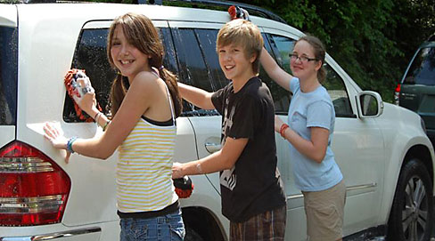
STEPS FOR SUCCESS:
- Use the “News Report Package” to help you. I gave this to you in class on Sept. 15th. If you cannot find your hardcopy, download the electronic package from our class website.
- Brainstorm (using brainstorming sheet)
- Write rough copy (use rubric to guide you)
- Edit (using the checklist to guide you)
- Type up good copy

