HPC30 - Raising Healthy Children
Final Exam Review

Part A - Knowledge and Understanding - Terms

Study the following 15 terms and definitions. 10 of them will show up on the exam. For the exam, you will be given the definitions, and the terms will be written on the whiteboard. You will need to match the terms with their respective definitions. The best way to study for this section is to use flashcards.

- Nuclear Family - A couple and their children (either one or more), regarded as a basic social unit.
- Miscarriage - A loss of a pregnancy in the first 20 weeks of development
- Permissive - A parenting style that is characterized by few rules and little parental control or guidance of children’s behaviour; the child may control the family.
- Zygote - After the sperm unites with the ovum, a new cell is created, which is called this.
- Circumcision - A procedure in which the foreskin is cut away from the head of the penis
- Ectopic pregnancy - A complication during pregnancy where the egg attaches outside of the uterus, which causes abdominal pains and bleeding.
- Epidural - A regional anesthetic provided through an injection into the spinal canal. It will cause the belly to numb, which helps relieve pain while giving birth.
- Infertility - The inability to conceive a child
- Breech Birth - When a baby is born with feet or buttocks first, instead of head first.
- Cystic Fibrosis - A health condition where the person has trouble breathing due to lung congestion, and they can’t efficiently draw nutrients from food. The person may look starved, though they eat more than normal.
- Postpartum Depression/Blues - Depression, anxiety, and possible anger sometimes felt by someone who has recently given birth. The feelings may surface as early as a few days after the baby is born, or several weeks later.
- Enuresis - bedwetting or lack of bladder control
- SIDS - Sudden infant death syndrome, also known as cot death or crib death, is the sudden unexplained death of a child less than one year of age.
- Apgar Scale - A method to quickly summarize the health of a newborn child. The child receives a score. They are scored based on their heart rate, breathing, muscle tone, responsiveness, and skin colour.
- Weaning - when an infant no longer bottle-feeds or breast-feeds and drinks from a cup

Part B - Thinking - Short Answer

Study the following 15 questions. 10 of them will show up on the exam. You will be expected to answer each question in 1-2 sentences.

- Name 2 good reasons to become a parent.
- I want to experience the joy and wonder that children provide
- I want to expand my family
- I want to teach and nurture a child
- My partner and I are ready to have have a child.
- I’m emotionally and financially ready to become a parent.

- What are the benefits of breastfeeding?
- It’s free and convenient
- Easier to digest than cow’s milk
- Carries antibodies
- Releases a hormone that stimulates the uterus to return to its usual condition
- Helps bond mother and baby

- Describe the difference between physical maturity and psychological maturity. Make sure you give some examples.
- The birth of a healthy baby depends in part on the mother’s level of physical maturity (if the mother’s body can handle a pregnancy). Psychological maturity is instead about the development of a person’s mind and emotions. These can be shown through behaviours and attitudes such as responsibility, the ability to set aside one’s own needs for another, self-motivation to reach goals, ability to make independent decisions, problem-solving skills, having a positive outlook, etc.

- Describe Sigmund Freud’s theory about child development.
- Childhood experiences, even when forgotten, affect a person’s actions and personality as an adult. The positive and negative sensory experiences infants associate with feeding and toilet-training affect personality.

- Describe Piaget’s theory of intellectual development.
- Children learn first by using their five senses. His theory doesn’t take emotions into consideration, but it did influence later research.

- Describe two consequences of teen pregnancy.
- Teenagers lack psychological maturity and are often not ready to be a parent
- Parents might not be financially able to help support their child’s pregnancy/raising their grandchild
- Might have to give up education to raise child
- Teen relationships often don’t work out
- Teens are less likely to seek the prenatal care that they need
- Many teens give birth to premature babies

- Describe (and explain) two of the most effective forms of birth control.
- Abstinence - no sexual intercourse
- Hormone Injection - given once every 3 months
- Oral Contraceptive - hormone pill taken daily

- What are two early signs of pregnancy?
- Missing a menstrual cycle
- Fatigue
- Enlarged and tender breasts
- Nausea
- Bloating
- Food cravings

- List two of the major vaccines that newborns should receive. Why is it important to get those vaccines?
- DTap - diphtheria, tetanus, pertussis, polio, and the flu. Important against breathing problems, heart failure, nerve damage, lockjaw, the flu, and whooping cough.
- Rotavirus - infection that causes vomiting and diarrhea in infants and children
- Pneumococcal disease - causes infections of the lungs, blood, brain, and spinal cord.

- Describe Kohlberg’s theory of moral development. What are the stages and what happens at each stage?
- Stage 1: PreConventional - children listen to their parents for fear of upsetting them
- Stage 2: Conventional - children learn reciprocity
- Stage 3: PostConventional - people learn the differences between what is right and wrong, and make their own independent decisions.

- What are the similarities and differences between a midwife and obstetrician?
- Midwife - both provide care but only an obstetrician can perform pregnancy-related surgery such as a c-section, or handle multiple births. A midwife is not certified to attend complicated pregnancies

- What should parents do when their child uses inappropriate language?
- Promote positive language instead, tell them not to use inappropriate language, remove the audience (e.g. tell the child to say the word by themselves in their room. If you take away the audience, saying the bad word is no longer exciting).

- What is a playgroup and provide the name of one that exists in Ottawa.
- An informal session where caregivers meet together and set up activities for their children in a relaxed environment. The parents might take turns watching the children. Do your own research on the internet to find local examples.

- Explain how parents can address common problems in families, such as death and unemployment.
- Death: explain that the child misbehaving did not cause the death, be gentle and honest (don’t hide the death), use clear simple language e.g. “when you die, your body stops working;” take the child to the funeral
- Unemployment: reassure children everything will be okay (calmly and confidently), remain positive and upbeat.

15. Why is positive communication from a parent so important to a child’s well-being?
- Good communication between a parent and child fosters a healthy relationship and atmosphere
- The family will become stronger
- Children feel important when they are listened to
- Helps build self-esteem in children
- Children feel rejected when their attempts to communicate are ignored

Part C - Communication - Diagrams

In this section, you will be asked to fill in the missing information on the diagrams.

- Study the following diagram on conception. 3 of the labels will be missing. You will have to identify the missing labels and explain the overall process of conception.
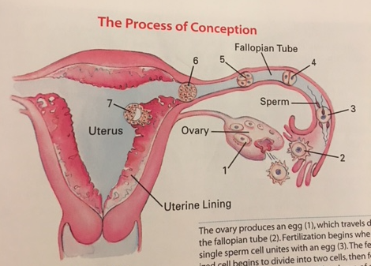
Overall Process: The ovary produces an egg (1), which travels down the fallopian tube (2). Fertilization begins when a single sperm cell unites with an egg (3). The fertilized cell begins to divide into two cells, then four, then eight, and so on (4 and 5). The clump of cells travels down the fallopian tube toward the uterus (6). Two weeks after conception the cells that will eventually form the baby are firmly planted in the uterine wall (7).

2. In the chart below, identify 2 key features: 1 that happens to the fetus and 1 that happens to the mother during each trimester

First Trimester  0-13 weeks | Second Trimester  14-26 weeks | Third Trimester
Zygote turns into an embryo, turns into a baby; Baby’s body structure and organ systems develop | Baby starts to move (might feel its movements); Organs mature, hair, eyelashes, teeth, muscles grow. Breathing beings. | Fetus hears sounds, fetus starts to descend into the pelvis to get ready for birth.
Mother may experience any of the following: nausea, fatigue, breast tenderness, frequent urination. Miscarriage may happen from 0-20 weeks. | Mother may experience: nausea, better sleep patterns, increased energy level, back pain, abdominal pain, leg cramps, constipation, heartburn. The mother starts showing during this time. Can find out the sex of your baby during this time. | Mother may experience: shortness of breath, hemorrhoids, varicose veins, sleeping problems, difficulty walking/bending over.

3. What are the 3 stages of childbirth?

Labour Pushing and Delivery Delivery of the Placenta

1
2
3
→ Contractions occur and → Lasts approx 2 hours → Mild contractions push the
Help dilate the cervix → Cervix is fully dilated placenta out of the birth canal
→ Lasts 10-30 minutes

Part D - Application - Scenarios
- If you had a child, would you choose home-based care or centre-based care for your child and why (2 marks)? Give an example of a local centre-based care facility.
- Home-based care: takes place in either the family’s or the caregiver’s home. Usually less structured and demanding. Is that an advantage or a drawback? That depends on your philosophy and the situation.
- Centre-based care: Facilities that provide supervised group care and socializing experiences by a trained staff. These centres are licensed and inspected by provincial authorities. Parents like them for their convenient hours and reliability. However, contact with so many other children increases the chance of illness. Also, a shy child may feel lost in group care. Also, good programs can be expensive and have long wait lists.

- If you had a child, would you use cloth or disposable diapers? Why (2 marks)?
- Cloth: cheaper, better for the environment, can use on future children, time-consuming to clean, have to use pins (sometimes), have to carry dirty diaper around
- Disposable: Easy and quick to use, bad for the environment, don’t have to carry around, expensive

- You are babysitting an 8 year old child. At the dinner table, the child chokes on a piece of food. Describe the procedure for performing the Heimlich maneuver on them. Take into consideration that they are either sitting or standing (1 mark)?

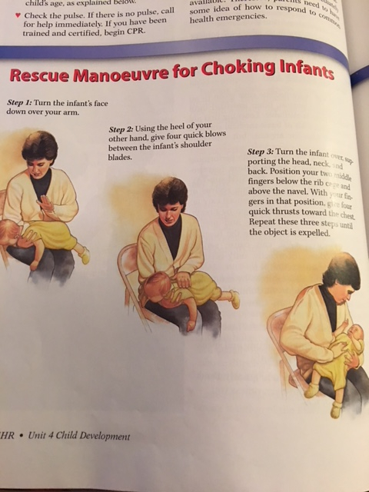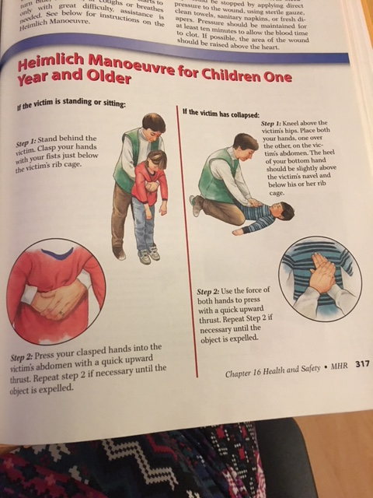

- Give an example of age-appropriate communication strategies for each of the following (3 marks):
  - Infants - high-pitched baby talk and silly words, imitate their sounds, sing to them, smile
  - Toddlers - use your natural voice to speak to them so they pick up proper grammar and language; don’t try to correct grammar
  - School-age children - don’t force them to talk if they aren’t in the mood, don’t try to converse with them when they are hungry, talk to them at bedtime by asking them about their day; talk to them as much as you can on walks, in the car, etc. Ask questions. Teach them how to be polite. For example, teach them that when someone is speaking, you have to wait your turn.

- Whenever you notice your three-year-old son, Marcus, is playing with his playmate. Marcus grabs a toy truck out of his playmate’s hand. What should you do (2 marks)?
- Explain that we don’t take things from others, and that he should have asked if he could play with the truck. Redirect the play: “You two have been playing trucks for a while. Why don’t you go draw?”

- What coping mechanisms are available to a parent who has just become unemployed?
- Put off large purchases, repair items instead of replacing them, value shop, prepare home-cooked meals, conserve energy around the house, volunteer in the meantime, stay upbeat

- Your child has become a picky-eater. She only wants to eat peanut butter and jam sandwiches for lunch and french fries for dinner. How should you respond to this?
- Your autistic child throws a temper tantrum in order to get their own way. How would you respond?
- Try not to show your frustration, reward even small signs of progress, use an object and/or activity that interests the child to draw them out of their isolation/fit. Remind the child of the rules of behaviour, and explain that they are currently not following the rules. Get help from a team of professionals to help guide you through future tantrums and problems.

- Describe your parenting philosophy. Make sure you reference one of the three parenting styles. Give specific examples that demonstrate your parenting style.
- Democratic - A parent who shares the decision-making with their child; the parent makes some or most of the decisions, but also lets the child make some of their own decisions.
- Permissive - A parent who lets their child make all of the decisions
- Authoritarian - A parent who makes all of the rules and decisions and the child must follow these rules/decisions.

